1. Open ShopPAK  
   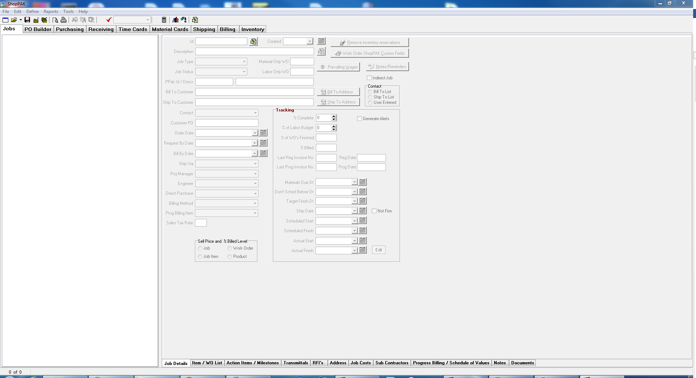
2. Open Job that needs to have Milestone Dates Assigned  
   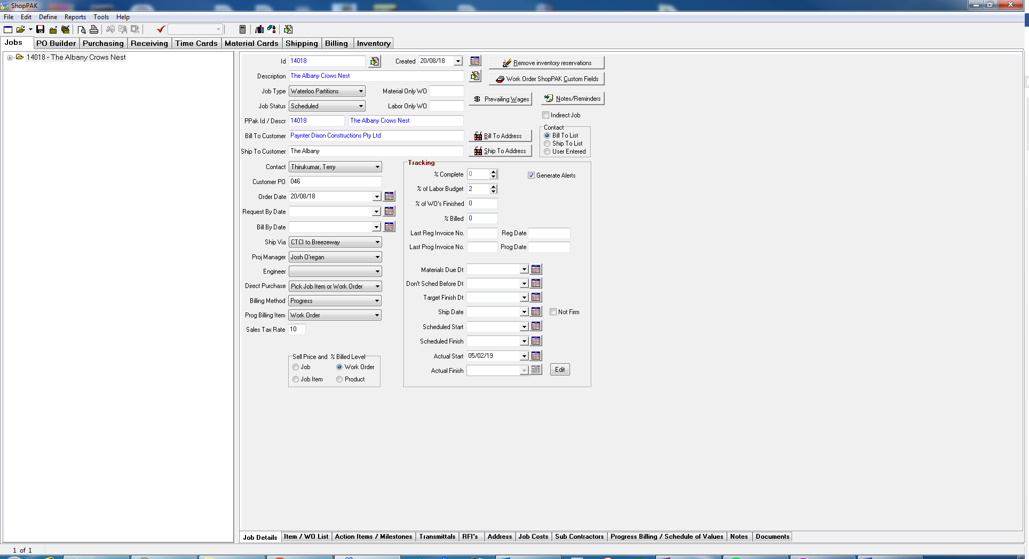
3. Open Action Items / Milestones tab  
   
4. Ensure that the milestones have been selected at the Work Order level.  
   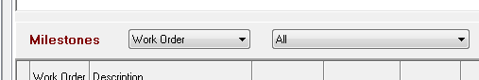
5. Right click row that needs dates assigned  
   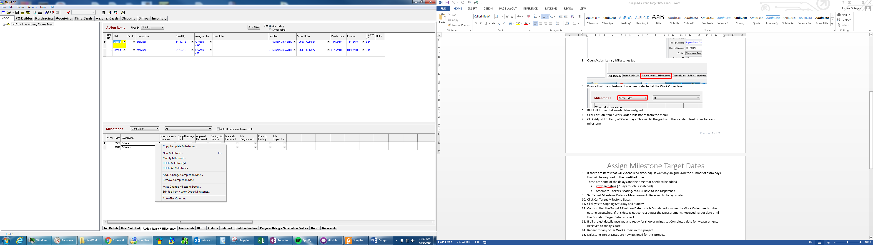
6. Click Edit Job Item / Work Order Milestones from the menu  
   
7. Click Adjust Job Item/WO Wait days. This will fill the grid with the standard lead times for each milestone.   
   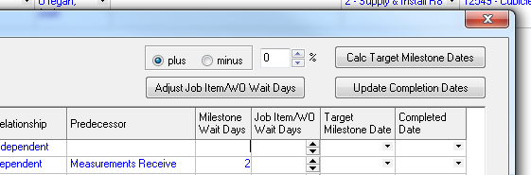
8. If there are items that will extend lead time, adjust wait days in grid. Add the number of extra days that will be required to the pre-filled time.   
   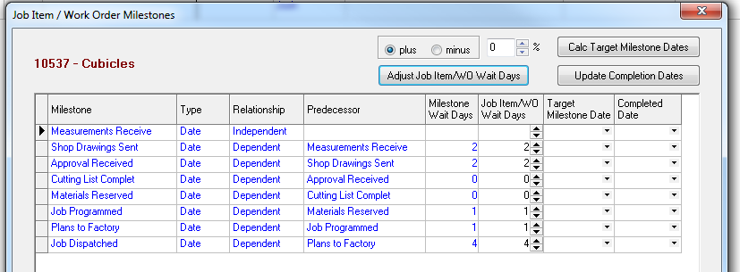  
   These are some of the delays and the time that needs to be added
   * Powdercoating (7 Days to Job Dispatched)
   * Assembly [Lockers, seating, etc.] (5 Days to Job Dispatched)
9. Set Target Milestone Date for Measurements Received to today’s date.  
   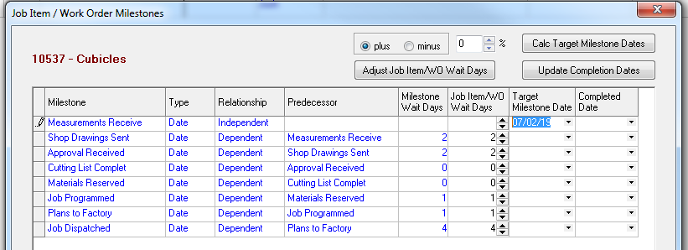
10. Click Calc Target Milestone Dates
11. Click yes to Skipping Saturday and Sunday  
    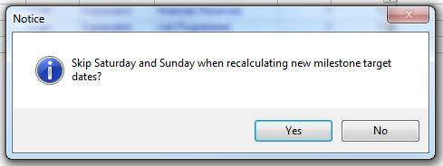
12. Confirm that the Target Milestone Date for Job Dispatched is when the Work Order needs to be getting dispatched. If this date is not correct adjust the Measurements Received Target date until the Dispatch Target Date is correct.   
    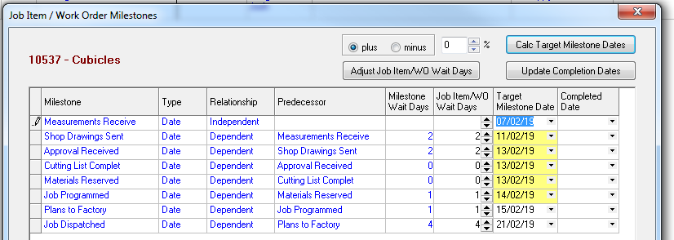
13. If all project details received and ready for shop drawings set Completed date for Measurements Received to today’s date  
    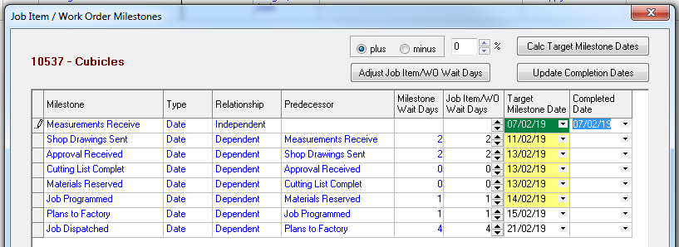
14. Click OK to apply dates to Milestone Template  
    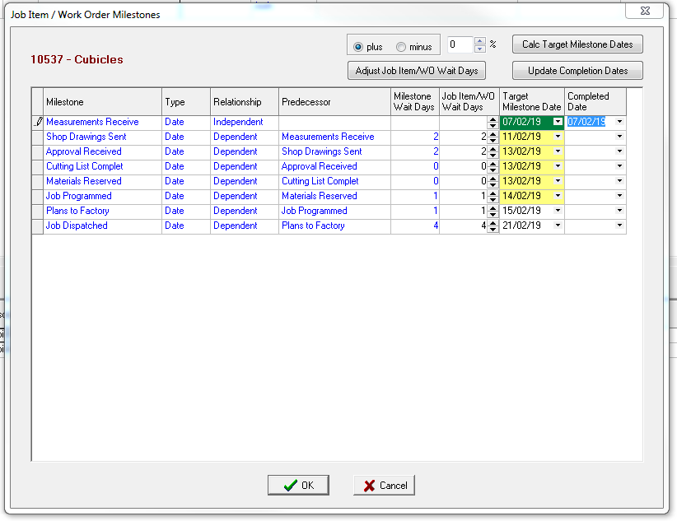
15. Repeat for any other Work Orders in this project  
    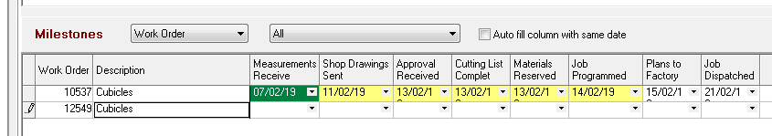
16. Milestone Target Dates are now assigned for this project.  
    